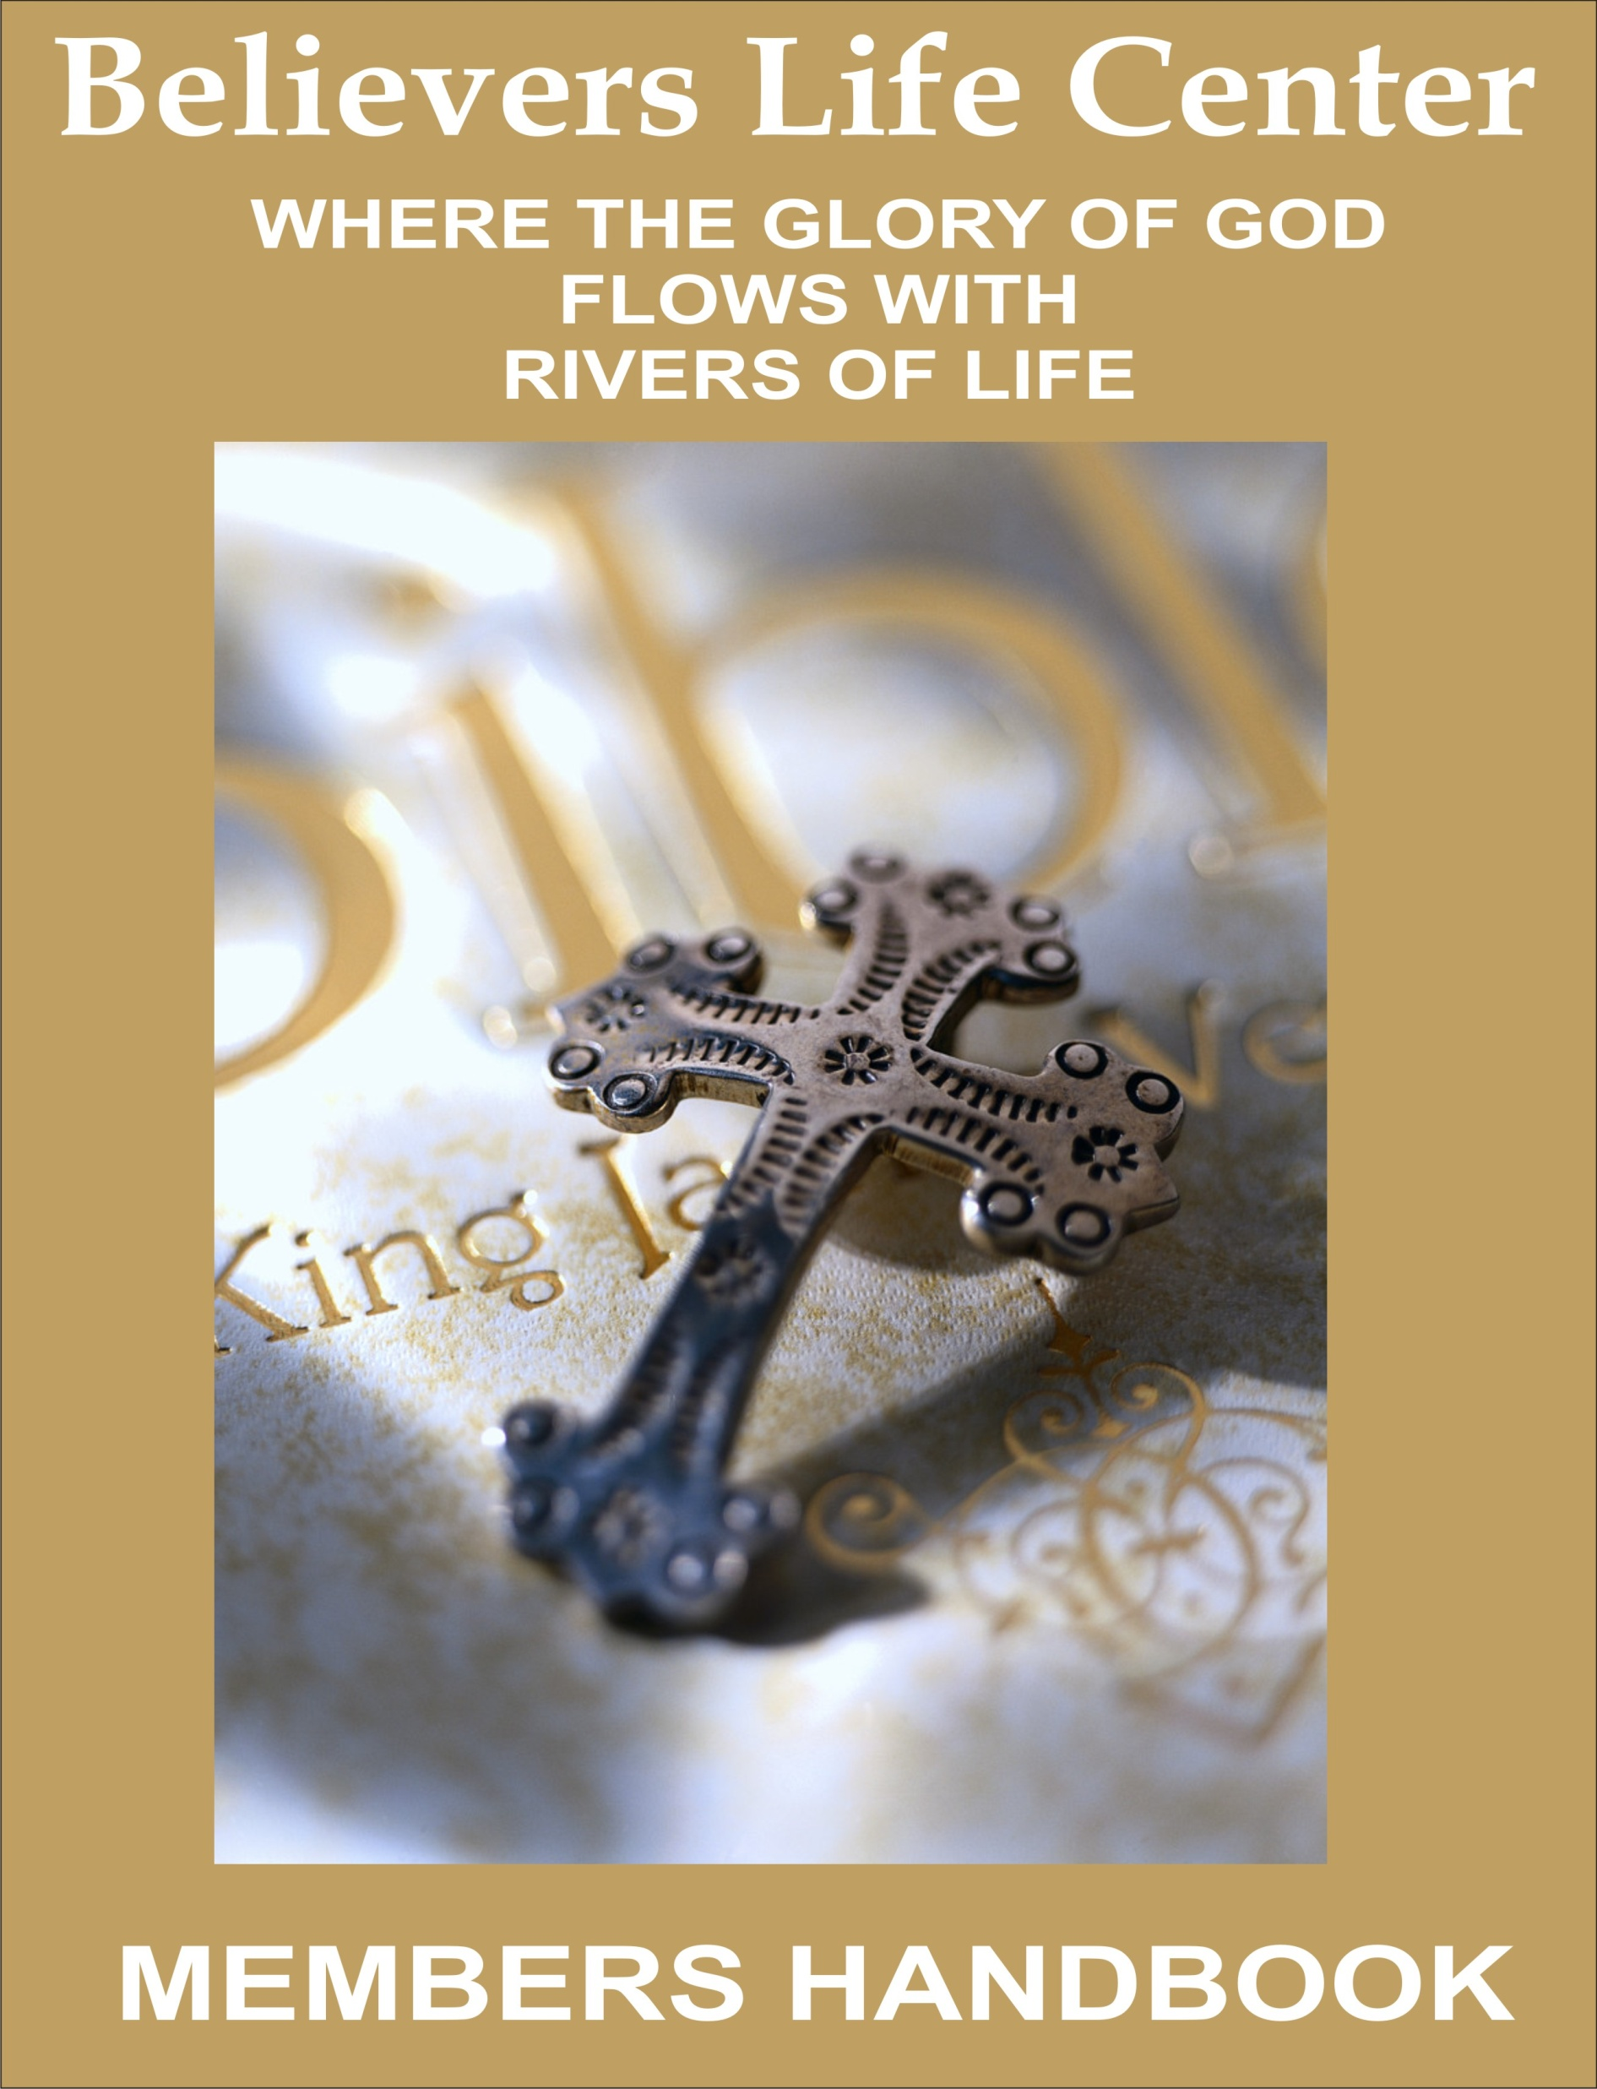

TABLE OF CONTENTS

PROFESSION OF SALVATION INTRODUCTION WELCOME … PAGE 4 HISTORY … PAGE 5 The Great Commission: How to Win People to Christ: … pAGE 8 OUR STATEMENT OF FAITH: WHAT WE BELIEVE FOUR ESSENTIAL TRUTHS … PAGE 9 WHAT IT MEANS TO BE A MEMBER … PAGE 11 MEMBERSHIP COVENANT … PAGE 12 HABIT ONE: BIBLE STUDY & PRAYER … PAGE 14
HOW TO GET MORE FROM MY BIBLE
TALKING WITH GOD

HABIT TWO: FELLOWSHIP WITH OTHER BELIEVERS

HABIT THREE: GROWING SPIRITUALLY BY LIVING

A SPIRIT LED LIFE … PAGE 19
HOW WAS THE HOLY SPIRIT FIRST REVEALED
WHO IS THE HOLY SPIRIT
WHAT DOES SPIRIT LED LIVING PRODUCE IN OUR LIVES?
LIVING A SUPERNATURAL LIFE
HOW DO I RECEIVE THE GIFT OF THE HOLY SPIRIT

HABIT FOUR: GIVING OF YOURSELF … PAGE 23
THREE AREAS OF GIVING
SEVEN BENEFITS OF GIVING
GIVING WITH THE RIGHT ATTITUDES

SCRIPTURE REFERENCES … PAGE 27

ACCEPTANCE OF OUR FAITH
TITHING … PAGE 34

MINISTRY DEPARTMENTS … PAGE 35

CHURCH MEMBERSHIP

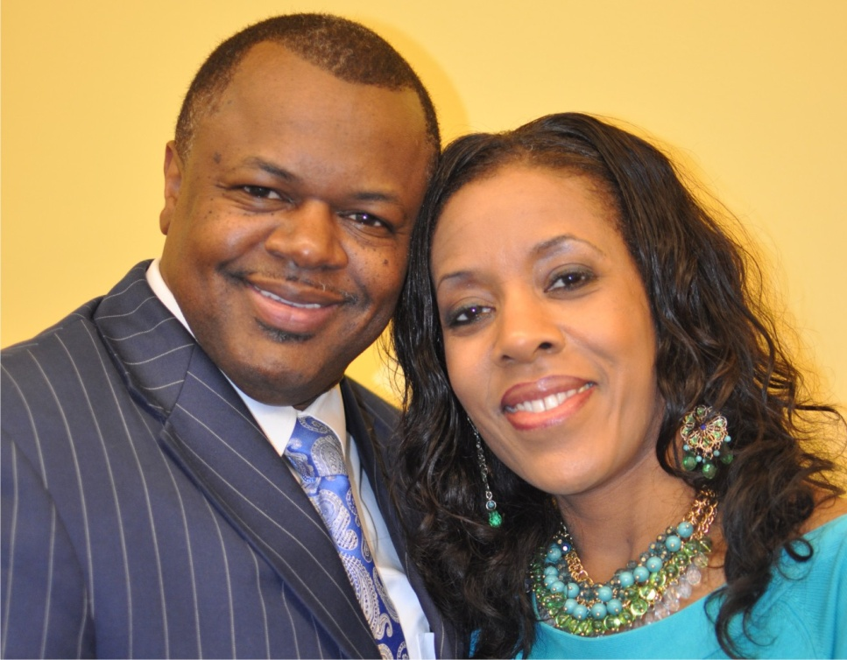
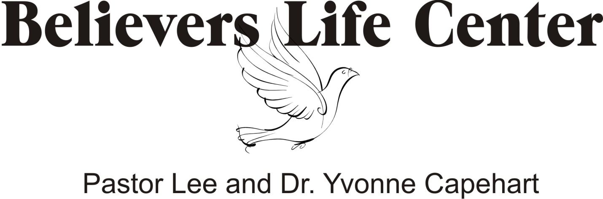
PROFESSION OF SALVATION

- In the beginning God created mankind in His image and after His likeness.
- Mankind was created to have dominion over the earth, and to worship God.
- God gave mankind the will to choose between good and evil.
- Mankind chose to violate God's law through disobedience (sin).
- Sin separated man from God.
- Mankind needs to be reconciled to God.
- Jesus's sacrifice on the cross brings mankind back into relationship with God.
- It doesn't matter what you have done in the past or how long you've been doing it!
- Once you accept the Lord Jesus Christ as your Savior, the Blood of Jesus covers your sins, and there is NO condemnation if you are in Christ Jesus and walk not after the flesh, but after the Spirit. (Romans 8:1)
- You can be restored back to your rightful place in God.
- As a result of your decision, you can begin to live the life that you were created to live, and worship Him as your Lord!
- Believe that God loves you
- Confess/Repent that you have sinned
- Receive the gift of salvation
- Apply God's word to your life
INTRODUCTION

WELCOME

We’re glad you’ve chosen to find out more about Believers Life Center! This manual is the basic introduction to our church family. Since we have members from many different church backgrounds, this manual was designed to clearly explain who we are and what we believe.

Believers Life Center History

In 1998 2BLEEV Ministries (aka) Believers Life Center, began a weekly bible study gathering of people eager to learn more about the Word of God. In these bible studies God’s anointing would fall and knowledge of his Word was being imparted by Pastor Lee and Dr. Yvonne Capehart. These small gatherings grew in no time.

Once we reached the mark, our Pastors decided it was time to take the leap of faith and move to a room in the Civic Center under the name of 2BLEEV Ministries. Services were awesome! The congregation grew.

In 2000 the Lord led Dr. Capehart to a building on Michigan Avenue. Within 2 weeks we had the keys and there we took under the new name of Believers Life Center. Awesome deliverance services took place in the new facility. God was really proving himself to be a KEEPER!

In a service as the anointing fell a word of prophesy was given to Dr. Capehart concerning a new building, stating that we would have one in 30 days.

That week the Lord led our Pastor to drive down Pace Blvd. As he drove he looked to the left and Lord spoke to him and said, “there is your new church.” He immediately contacted the owner of the building and within 30 days we received the keys.

In 2006 we moved in and dedicated the building in November of that year. In this location we hosted many conference, seminars and other great moves of God.

In 2011 we received yet another elevation. We have now moved into a new location, where we have 4 separate buildings. A beautifully remodeled sanctuary, a fellowship hall, a children’s church and a youth department.

We are set to invade Pensacola and take this city for God. With Gods help we are looking to soon out grow this facility and move even further into the blessings of the Lord.

KEY TRUTHS

1. The church is a Spiritual Family.

2. God expects you to be a Member of a church family.

3. A Christian without a church family is an Orphan.

THE GOAL OF THIS MANUAL:

That I will commit myself to Christ and to the Believers Life Center Family _.

The Great Commission:
“He said unto them, ‘Go into all the world and preach the good news to all creation. Whoever believes and is baptized will be saved, but whoever does not believe will be condemned. And these signs will accompany those who believe…’ Then the disciples went out and preached everywhere, and the Lord worked with them and confirmed his word by the signs that accompanied it.”
Mark 16:15-20

“We proclaim Him, admonishing and teaching everyone with all wisdom, that we may present everyone perfect in Christ. To this end I labor, struggling with all energy, which so powerfully works in me.”
Colossians 1:28-29

1. “We proclaim Him” is Evangelism.

2. “Admonishing everyone” is Pastoral Care.

3. “Teaching everyone” is Discipleship.

4. “Present everyone perfect” is Ministry.

How to Win People to Christ:

1. Accept the personal Responsibility.

2. Build a personal Relationship.

3. Share your personal Story.

4. Give a personal Invitation.

OUR STATEMENT OF FAITH: WHAT WE BELIEVE

1. In essential beliefs, we have unity.
“There is one Body and one Spirit...there is one Lord, one faith, one baptism, and one God and Father of us all…”
Ephesians 4:4-6

2. In non-essential beliefs, we have liberty.
“Accept him whose faith is weak, without passing judgment on disputable matters...Who are you to judge someone else’s servant? To his own master he stands or falls...So then each of us will give an account of himself to God...So whatever you believe about these things keep between yourself and God.”
Romans 14:1, 4, 12, 22

3. In all our beliefs, we show charity.
“...If I hold in my mind not only all human knowledge but also the very secrets of God, and if I have the faith that can move mountains - but have no love, I amount to nothing at all.”
1 Corinthians 13:2 (Ph)

I. FOUR ESSENTIAL TRUTHS

1. The Bible is the Word of God.
“All Scripture is inspired by God and is useful to teach us what is true and to make us realize what is wrong in our lives. It straightens us out and teaches us to do what is right.”
2 Timothy 3:16 NLT

“We also thank God continually because, when you received the Word of God which you heard from us, you accepted it, not as the word of men, but actually as it is, the Word of God, which is at work in you who believe.”
1 Thessalonians 2:13

God’s Word is the only completely reliable and truthful authority and we accept the Bible as our manual for living. Our first question when faced with a decision is, “What does the Bible say?” We practice daily Bible reading and Bible study. The Bible is the basis for all we believe.

2. Jesus Christ is the Son of God.
Jesus answered, “I am the way and the truth and the life. No one comes to the Father except through me.”
John 14:6

“For Jesus is the one referred to in the Scriptures, where it says, ‘The stone that you builders rejected has now become the cornerstone.’ There is salvation in no one else! There is no other name in all of heaven for people to call on to save them.”
Acts 4:11-12 NLT

Jesus Christ, second Person of the Trinity, lived a sinless life on earth and voluntarily paid for our sin by dying on the cross as our substitute. This accomplished salvation for all who receive grace by trusting in Him alone. He rose from the dead and is the only mediator between God and us. He baptizes believers in the Holy Spirit and will return to earth to consummate history.

3. You must be Born Again .
“When anyone becomes a Christian he becomes a new person inside. The old passes away, a new life has begun.”
2 Corinthians 5:17 LB

Jesus: “If you try to keep your life for yourself, you will lose it. But if you give up your life for me, you will find true life.”
Matthew 16:25 NLT

God created humans to have fellowship with Him, but they defied God by sinfully going their own way. As a result, we need God’s saving grace to end our alienation from Him. Salvation comes only through God’s grace - not human effort - and must be received personally by repentance and faith. At the end, everyone will experience bodily resurrection and the judgment. Only believers will enjoy eternal fellowship with God.

4. Believers can be Spirit-Filled and Spirit-Lead .
“...you will receive power when the Holy Spirit comes on you...”
Acts 1:8

“...be filled with the Holy Spirit”
Ephesians 5:18

“If you then, though you are evil, know how to give good gifts to your children, how much more will your Father in heaven give the Holy Spirit to those who ask him!”
Luke 11:13

We believe the only way possible to live the Christian life is by God’s power within us. Every believer can be filled with the Holy Spirit by simply asking. We seek to practice a daily dependence on God’s Spirit to enable us to do what is right.
II. WHAT IT MEANS TO BE A MEMBER

The difference between “attenders” and “members” can be summed up in one word: Commitment.

An Attender is a Consumer.

A Member is a Contributor.

At Believers Life Center we recognize the need for a formal membership.
We ask you to commit to membership for 4 reasons:

1. A Biblical Reason: Christ is committed to the church.
“...Christ loved the church, and he gave his life for it.”
Ephesians 5:25

2. A Cultural Reason: It is an antidote to our society.
We live in an age where very few want to be committed to anything...a job...a marriage...our country. This attitude has even produced a generation of “church shoppers and hoppers”. Membership swims against the current of America’s “consumer religion.” It is an unselfish decision. Commitment always builds character.

3. A Practical Reason: It defines who can be counted on.
Every team must have a roster. Every school must have an enrollment. Every business has a payroll. Every army has an enlistment. Even our country takes a census and requires voter registration. Membership identifies our family.

4. A Personal Reason: It produces spiritual growth.
The New Testament places a major emphasis on the need for Christians to be accountable to each other for spiritual growth. You cannot be accountable when you’re not committed to any specific church family.
III. BELIEVERS LIFE CENTERS MEMBERSHIP COVENANT

Having received Christ as my Lord and Savior and being in agreement with the values and ideas presented in the Church 101 class, I now feel led by the Holy Spirit to unite with the Believers Life Center family. In doing so, I commit myself to God and to the other members to do the following:

1. I will protect the unity of my church...

...By acting in love toward other members

...By refusing to gossip

...By following the leaders

“So let us concentrate on the things which make for harmony, and on the growth of our fellowship together.”
Romans 14:19 (Ph)

“Live in complete harmony with each other - each with the attitude of Christ toward each other.”
Romans 15:5 (LB)

“Have a sincere love for your fellow believers, love one another earnestly with all your hearts.”
1 Peter 1:22 (GN)

“Do not let any unwholesome talk come out of your mouths, but only what is helpful for building others up according to their needs…”
Ephesians 4:29

“Obey your leaders and submit to their authority. They keep watch over you as men who must give an account. Obey them so that their work will be a joy, not a burden, for that would be no advantage to you.”
Hebrews 13:17

2. I will share the responsibility of my church...

...By praying for its growth

...By inviting the unchurched to attend

...By warmly welcoming those who visit

“To the church...we always thank God for you and pray for you constantly.”
1 Thessalonians 1:2

“Go out into the country…and urge anyone you find to come in, so that My House will be full.”
Luke 14:23 (LB)
“So warmly welcome each other into the church, just as Christ has warmly welcomed you; then God will be glorified.”
Romans 15:7 (LB)

3. I will serve the ministry of my church...

...By discovering my gifts and talents

...By being equipped to serve by my pastors

...By developing a servant’s heart

“Serve one another with the particular gifts God has given each of you...”
1 Peter 4:10 (Ph)

“God gave...some to be pastors and teachers to prepare God’s people for works of ministry, so that the body of Christ may be built up…”
Ephesians 4:11-12

“Each of you should look not only to your own interests, but also to the interests of others. Your attitude should be the same as that of Jesus Christ...who took on the very nature of a servant...”
Philippians 2:3-4, 7

4. I will support the testimony of my church...

...By attending church

...By living a godly life

...By giving regularly

“They devoted themselves to the apostles’ teaching and to the fellowship, to the breaking of bread and to prayer.”
Acts 2:42

“Let us not give up the habit of meeting together...but let us encourage one another.”
Hebrews 10:25

“Each one of you, should set aside a specific sum of money in proportion to what you have earned and use it for the offering.”
1 Corinthians 16:2

“A tenth of all you produce is the Lord’s, and it is holy.”
Leviticus 27:30
Habit One: Bible Study & Prayer

Getting a Grasp on God’s Word

“The whole Bible was given to us by inspiration from God and is useful to teach us what is true and to make us realize what is wrong in our lives; it straightens us out and helps us do what is right. It is God’s way of making us well prepared at every point, fully equipped to do good to everyone.”
2 Timothy 3:16-17 (LB)

I. HOW TO GET MORE FROM MY BIBLE

1. I must Accept its authority

Your attitude toward the Bible makes a huge difference.

“We also thank God continually because, when you received the Word of God which you heard from us, you accepted it, not as the word of men, but actually as it is, the Word of God, which is at work in you who believe.”
1 Thessalonians 2:13

We believe in the closed canon of scripture:

A. There are not, nor will there ever be, any other books, verses or ideas added to the Bible or placed beside it as equal in authority or revelation.

B. All preaching, teaching, prophesying or any other communication being declared in the name of the Lord is to be subject to measurement by the content of the Word of God.

2. I must Assimilate its truths

A. Hearing God’s Word

“Faith comes from hearing the Word of God.”
Romans 10:17

B. Reading God’s Word

“Happy is the one who reads this book ... and obeys what is written in it!”
Revelation 1:3 GN

How often should I read God’s Word? DAILY.

“(The Scriptures) shall be his constant companion. He must read from it everyday of his life so that he will learn to respect the Lord his God by obeying all of his commands.”
Deuteronomy 17:19 LB
C. Studying God’s Word
“...they accepted the message eagerly and studied the Scriptures everyday ...”
Acts 17:11 Ph

D. Memorizing God’s Word
“Guard my words as your most precious possession. Write them down, and also keep them deep within your heart.”
Proverbs 7:2-3 LB

E. Meditating on God’s Word
“(Those) who are always meditating on His Laws ... are like trees along a river bank bearing fruit ... they never wither and whatever they do prospers.”
Psalm 1:2-3 LB

Meditation is Focused Thinking about a Bible verse in order to discover how to apply its truth to life.

F. Receiving God’s Word with an open Heart
“Those on the rock are the ones who receive the Word with joy when they hear it, but they have no roots... Therefore consider carefully how you listen.”
Luke 8:13-18

The word “receive” is dechomai in the Greek It literally means “to welcome”

3. I must Apply its principles
“Once you know these things you will be blessed if you do them.”
John 13:17

“Do not merely listen to the word, and so deceive yourselves. Do what it says.”
James 1:22

A. Claim His promises
Battles – 1 John 4:4, Luke 10:19, Rom. 8:37
Money – Philippians 4:19, Psalm 1:1-3
Fear – Psalm 27:1
Sickness – Psalm 103:3
Confidence – 2 Corinthians 3:6
Safety – Psalm 121:8

B. Share it with others

How, then, can they call on the one they have not believed in? And how can they believe in the one of whom they have not heard? And how can they hear without someone preaching to them?
Romans 10:14
C. How to Apply Scripture:

1st ask: What did it mean to the original hearers?

2nd ask: What is the underlying timeless principle?

3rd ask: How could I practice that principle?

II. Talking with God

Always be joyful. Never stop praying.
1 Thessalonians 5:16-17(NLT)

In the beginning we were created to have fellowship with God but because of Adam’s fall Jesus sacrificed Himself to make a relationship with God possible.

Jesus exampled a personal relationship with God through prayer, that gave Him great strength.

Every person who has ever been effective in service for God has developed this habit. The only way to be a healthy Christian is to commune with God daily through prayer!

1. The purpose of daily prayer time

A. To Give devotion to God.
“(Hezekiah) was successful, because everything he did ... he did in a spirit of complete devotion to his God.”
2 Chronicles 31:21 GN

B. To Get direction from God.
“Show me the path where I should go, O Lord; point out the right road for me to walk. Lead me ...”
Psalm 25:4 LB

C. To Gain delight in God.
“Delight yourself in the Lord; and he will give you the desires of your heart.”
Psalm 37:4 KJV

D. To Grow more like God.
“Jesus has the power of God, by which he has given us everything we need to live and to serve God. We have these things because we know him…. With these gifts you can share in being like God”
2 Peter 1:4 NCV
2. How to begin a daily prayer time

A. Select a specific Time and Place .

B. Follow a simple Plan.

How to Spend Fifteen Minutes with God:

1. Read a verse. (4 Minutes)

2. Reflect on the verse. (4 Minutes)

3. Record what God desires of you. (3 Min.)

4. Request from God. (4 Minutes)

“Let us not get tired of doing what is right, for after a while we will reap a harvest of blessing if we don’t get discouraged and give up.”
Galatians 6:9 LB

3. Use the model Jesus gave us
“This, then, is HOW you should pray ...”
Matthew 6:9-15

A. Praise: I begin by expressing Love to God.
“Our Father in heaven, hallowed be your name…”

B. Purpose: I commit myself to doing God’s Will.
“Your kingdom come, your will be done, on earth as it is in heaven...”

C. Provision: I ask God to Provide my daily needs.
“Give us today our daily bread...”

D. Pardon: I ask God to Forgive my sins.
“Forgive us our debts...”

E. People: I pray for Other people.
“...as we have also forgive our debtors.”

F. Protection: I ask for Spiritual protection.
“And lead us not into temptation but deliver us from the evil one.” (vs. 13)
Habit Two: Fellowship with Other Believers

“Let us not give up the habit of meeting together, as some are doing. Instead, let us encourage each other.”
Hebrews 10:25 (GN)

How can a church grow large yet maintain close friendships?

At Believers Life Center, we believe our church must grow LARGER and SMALLER at the same time.

Habit Three: Growing Spiritually by Living a Spirit Led Life

“Gathering them together, He commanded them not to leave Jerusalem, but to wait for what the Father had promised, “Which,” He said, “you heard of from Me; for John baptized with water, but you will be baptized with the Holy Spirit not many days from now… you will receive power when the Holy Spirit has come upon you; and you shall be My witnesses both in Jerusalem, and in all Judea and Samaria, and even to the remotest part of the earth.”
Acts 1:4-8

I. HOW WAS THE HOLY SPIRIT FIRST REVEALED?
“When the day of Pentecost came, they were all together in one place. Suddenly a sound like the blowing of a violent wind came from heaven and filled the whole house where they were sitting. They saw what seemed to be tongues of fire that separated and came to rest on each of them. All of them were filled with the Holy Spirit and began to speak in other tongues as the Spirit enabled them.”

“Then Peter stood up with the Eleven, raised his voice and addressed the crowd: ‘Fellow Jews and all of you who live in Jerusalem, let me explain this to you; listen carefully to what I say. These men are not drunk, as you suppose. It’s only nine in the morning! No, this is what was spoken by the prophet Joel: “In the last days, God says, I will pour out my Spirit on all people.
Acts 2:1-17

II. WHO IS THE HOLY SPIRIT?

1. The Holy Spirit is a Person.
“I will ask the Father, and He will give you another Helper, that He may be with you forever…”
John 14:16

2. The Third Person in the Trinity.
“But the Helper, the Holy Spirit, whom the Father will send in My name, He will teach you all things, and bring to your remembrance all that I said to you.”
John 14:26
III. WHAT DOES SPIRIT LED LIVING PRODUCE IN OUR LIVES?

1. Comfort.
“And I will pray the Father, and he shall give you another Comforter, that he may abide with you for ever…”
John 14:16 KJV

2. Conviction.
“But now I am going to Him who sent Me; and none of you asks Me, ‘ Where are You going?’ “But because I have said these things to you, sorrow has filled your heart. “But I tell you the truth, it is to your advantage that I go away; for if I do not go away, the Helper will not come to you; but if I go , I will send Him to you. “And He, when He comes , will convict the world concerning sin and righteousness and judgment…”
John 16:5-8

3. Guidance.
“But when He, the Spirit of truth, comes, He will guide you into all the truth; for He will not speak on His own initiative, but whatever He hears, He will speak; and He will disclose to you what is to come.”
John 16:13

4. Power.
“But you will receive power when the Holy Spirit comes on you; and you will be my witnesses in Jerusalem, and in all Judea and Samaria, and to the ends of the earth.”
Acts 1:8

5. Character.
“But the fruit of the Spirit is love, joy, peace, patience, kindness, goodness, faithfulness, gentleness and self-control.”
Galatians 5:22-23

6. Spiritual Gifts ..
“There are different kinds of gifts, but the same Spirit… Now to each one the manifestation of the Spirit is given for the common good. To one there is given through the Spirit the message of wisdom, to another the message of knowledge by means of the same Spirit, to another faith by the same Spirit, to another gifts of healing by that one Spirit, to another miraculous powers, to another prophecy, to another distinguishing between spirits, to another speaking in different kinds of tongues, and to still another the interpretation of tongues. All these are the work of one and the same Spirit, and he gives them to each one, just as he determines.”
1 Corinthians 12:4-11
IV. LIVING A SUPERNATURAL LIFE

One of the main purposes of the work of the Holy Spirit in our lives is to connect us to the heavenly realms.

“And God raised us up with Christ and seated us with him in the heavenly realms in Christ Jesus, in order that in the coming ages he might show the incomparable riches of his grace, expressed in his kindness to us in Christ Jesus.”
Ephesians 2:6-7

“However, as it is written: “No eye has seen, no ear has heard, no mind has conceived what God has prepared for those who love him” — but God has revealed it to us by his Spirit. The Spirit searches all things, even the deep things of God.”
1 Corinthians 2:9-10

"In the last days, God says, I will pour out my Spirit on all people. Your sons and daughters will prophesy, your young men will see visions, your old men will dream dreams. Even on my servants, both men and women, I will pour out my Spirit in those days, and they will prophesy. I will show wonders in the heaven above and signs on the earth below… And everyone who calls on the name of the Lord will be saved.”
Acts 2:17-21

God desires to give us:

1. Dreams .
A dream is a picture you have in your mind of a desired future; that which gets inside of you and is beyond reason and is bigger than you on your own.

2. Visions .
A vision is that which is seen, an awake dream; you see something already done; you see something in “How to Steps”.

3. Prophecy .
To prophesy is to speak forth biblical truth in the mind and counsel of God that cannot be known through natural means.

V. HOW DO I RECEIVE THE GIFT OF THE HOLY SPIRIT?

1. Remove all barriers.
Peter replied, “Repent and be baptized, every one of you, in the name of Jesus Christ for the forgiveness of your sins. And you will receive the gift of the Holy Spirit.
Acts 2:38
2. Request the Holy Spirit.
“Now suppose one of your fathers is asked by his son for a fish; he will not give him a snake instead of a fish, will he? “Or if he is asked for an egg, he will not give him a scorpion, will he? “If you then, being evil, know how to give good gifts to your children, how much more will your heavenly Father give the Holy Spirit to those who ask Him?”
Luke 11:11-13

3. Release the gifts.
“Each one should use whatever gift he has received to serve others, faithfully administering God’s grace in its various forms.”
1 Peter 4:10
Habit Four: Giving of Yourself

“Just as you excel in everything else... in faith, in speech, in knowledge, in complete earnestness... see that you also excel in the grace of giving.”
2 Corinthians 8:7

I. THREE AREAS OF GIVING

1. Give of your Time .
Therefore be careful how you walk, not as unwise men but as wise, making the most of your time, because the days are evil.
Ephesians 5:15-16 NAS

2. Give of your Talents .
A spiritual gift is given to each of us so we can help each other.
1 Corinthians 12:7 NLT

3. Give of your Treasure .
If your gift is… giving, give generously.
Romans 12:8 NLT

“Yes, you should tithe, and you shouldn’t leave the more important things undone either.”
Matthew 23:23

II. SEVEN BENEFITS OF GIVING

1. Giving makes me become like God .
“God so loved the world that He gave his only Son...”
John 3:16

2. Giving draws me Closer to God.
“Where your treasure is, there your heart is also.”
Matthew 6:21

3. Giving is the antidote to Materialism.
“Command those who are rich in this present world not to be arrogant nor to put hope in wealth, which is so uncertain, but to put their hope in God, who richly provides us with everything for our enjoyment. Command them to be generous and willing to share. In this way they may take hold of the life that is truly Life!”
1Timothy 6:17-19
4. Giving strengthens my Faith .
“Trust in the Lord with all your heart and lean not on your own understanding. Honor the Lord by giving him the first part of your income, and he will fill your barns to overflowing.”
Prov. 3:5, 9

“Give and it will be given to you ... For with the measure you use, it will be measured back to you.”
Luke 6:38

5. Giving is an investment in Eternity .
“...Give happily to those in need, and always be ready to share whatever God has given you. By doing this, you will be storing up real treasure for yourselves in heaven - it is the only safe investment for eternity.”
1Timothy 6:18-19 LB

6. Giving Blesses me in return.
“A generous man himself will be blessed.”
Proverbs 22:9

“A generous man will prosper; he who refreshes others will himself be refreshed.”
Proverbs 11:25

7. Giving makes me Happy .
(Jesus) “There is more happiness in giving than in receiving.”
Acts 20:35 LB

III. GIVING WITH THE RIGHT ATTITUDES

1. Give Willingly .
“For if the willingness is there, your gift is acceptable according to what you have, not according to what you don’t have.”
2 Corinthians 9:12

“Each one should give what he has decided in his heart to give, not reluctantly or under pressure ...” I Corinthians 9:7a

2. Give Cheerfully .
“...for God loves a cheerful giver!”
2 Corinthians 9:7b

3. Give Sacrificially .
“They gave as much as they were able, and even beyond their ability. Entirely on their own, they urgently pleaded with us for the privilege of sharing in this service ...”
2 Corinthians 8:3-4
4. Give Expectantly.
“Remember this: Whoever sows sparingly will also reap sparingly; and whoever sows generously will reap generously.”
2 Corinthians 9:6

Scripture References

The following contains definitions of the Spiritual gifts. While not meant to be dogmatic or final, these definitions and supporting scriptures do correspond to characteristics of the gifts as expressed in the Gifts Questionnaire.

A. APOSTLESHIP
The gift of apostleship is the divine strength or ability to pioneer new churches and ministries through planting, overseeing, and training. Acts 15:22-35, I Cor. 12:28, II Cor. 12:12, Gal 2:7-10, Ephesians 4:11-14

B. DISCERNMENT
The gift of discernment is the divine strength or ability to spiritually identify falsehood and to distinguish between right and wrong motives and situations.
Matt. 16:21-23, Acts 5:1-11, 16:16-18, I Cor. 12:10, I John 4:1-6

C. EVANGELISM
The gift of evangelism is the divine strength or ability to help non-Christians take the necessary steps to becoming a born again Christian. Acts 8:5-6, Acts 8:26-40, Acts 14:21, Acts 21:8, Ephesians 4:11-14

D. EXHORTATION
The gift of exhortation is the divine strength or ability to encourage others through the written or spoken word and Biblical truth. Acts 14:22, Romans 12:8, I Tim. 4:13, Heb 10:24-25

E. FAITH
The gift of faith is the divine strength or ability to believe in God for unseen supernatural results in every arena of life. Acts 11:22-24, Rom 4:18-21, I Cor. 12:9, Hebrews 11

F. GIVING
The gift of giving is the divine strength or ability to produce wealth and to give by tithes and offerings for the purpose of advancing the Kingdom of God on earth. Mark 12:41-44, Romans 12:8, II Cor. 8:1-7, 9:2-7
G. HEALING
The gift of healing is the divine strength or ability to act as an intermediary in faith, prayer, & by the laying on of hands for the healing of physical and mental illnesses.
Acts 3:1-10, Acts 9:32-35, Acts 28:7-10, I Cor. 12:9, 28

H. HELPS
The gift of helps is the divine strength or ability to work in a supportive role for the accomplishment of tasks in Christian ministry. Mark 15:40-41, Acts 9:36, Romans 16:1-2, I Cor 12:28

I. HOSPITALITY
The gift of hospitality is the divine strength or ability to create warm, welcoming environments for others in places such as your home, office, or church. Acts 16:14-15, Romans 12:13, Romans 16:23, Heb 13:1-2, I Peter 4:9

J. INTERCESSION
The gift of intercession is the divine strength or ability to stand in the gap in prayer for someone, something, or someplace believing for profound results. Heb 7:25, Col 1:9-12, Col 4:12-13, Jas 5:14-16

L. KNOWLEDGE
The gift of knowledge is the divine strength or ability to bring clarity and to understand situations and circumstances often accompanied by a word from God. Acts 5:1-11, I Cor. 12:8, Col 2:2-3

M. LEADERSHIP
The gift of leadership is the divine strength or ability to influence people at their level while directing and focusing them on the big picture, vision, or idea. Romans 12:8, I Tim. 3:1-13, I Tim. 5:17, Hebrews 13:17

N. MIRACLES
The gift of miracles is the divine strength or ability to alter the natural outcomes of life in a supernatural way through prayer, faith, and divine direction.
Acts 9:36-42, 19:11-12, 20:7-12, Rom 15:18-19, I Cor. 12:10, 28

O. MISSIONARY
The gift of missions is the divine strength or ability to reach others outside of your culture and nationality; while in most cases living in that culture or nation. Acts 8:4, Acts 13:2-3, Acts 22:21, Romans 10:15

P. MUSIC / WORSHIP
The gift of music / worship is the divine strength or ability to sing, dance, or play an instrument primarily for the purpose of helping others worship God.
Deut. 31:22, I Sam. 16:16, I Chronicles 16:41-42, II Chronicles 5:12-13, 34:12, Psalm 150

Q. PASTOR / SHEPHERD
The gift of pastor / shepherd is the divine strength or ability to care for the personal needs of others by nurturing and mending life issues. John 10:1-18, Eph 4:11-14, I Tim 3:1-7, I Peter 5:1-3

R. PROPHECY
The gift of prophecy is the divine strength or ability to boldly speak and bring clarity to scriptural and doctrinal truth, in some cases foretelling God’s plan. Acts 2:37-40, Acts 7:51-53, Acts 26:24-29, I Cor. 14:1-4, I Thess. 1:5

S. TEACHING
The gift of teaching is the divine strength or ability to study and learn from the Scriptures primarily to bring understanding and depth to other Christians. Acts 18:24-28, Acts 20:20-21, I Cor. 12:28, Eph 4:11-14

T. TONGUES (and Interpretation)
The gift of tongues is the divine strength or ability to pray in a heavenly language to encourage your spirit and to commune with God. The gift of tongues is often accompanied by interpretation and should be used appropriately.
Acts 2:1-13, I Cor. 12:10, 14:1-14

U. WISDOM
The gift of wisdom is the divine strength or ability to apply the truths of Scripture in a practical way, producing the fruitful outcome and character of Jesus Christ. Acts 6:3,10, I Cor. 2:6-13, I Cor. 12:8

BELIEVERS LIFE CENTERS ACCEPTANCE OF OUR FAITH

HOLY BIBLE
The Holy Bible, and only the Bible, is the authoritative Word of God. It alone is the final authority in determining all doctrinal truths. In its original writing, it is inspired, infallible and inerrant (II Timothy 3:16; II Peter 1:20-21; Proverbs 30:5; Romans 16:25-26).

TRINITY
There is one God, eternally existent in three persons: Father, Son and Holy Spirit. These three are coequal and co-eternal (I John 5:7; Genesis 1:26; Matthew 3:16-17, 28:19; Luke 1:35; Isaiah 9:6; Hebrews 3:7-11).

JESUS CHRIST
Jesus Christ is God the Son, the second person of the Trinity. On earth, Jesus was 100% God and 100% man. He is the only man ever to have lived a sinless life. He was born of a virgin, lived a sinless life, performed miracles, died on the cross for mankind and thus, atoned for our sins through the shedding of His blood. He rose from the dead on the third day according to the Scriptures, ascended to the right hand of the Father, and will return again in power and glory. (John 1:1,14, 20:28; I Timothy 3:16; Isaiah 9:6; Philippians 2:5-6; I Timothy 2:5).

REDEMPTION
Man was created good and upright, but by voluntary transgression he fell; his only hope of redemption is in Jesus Christ, the Son of God (Gen. 1:26-31, 3:1-7; Romans 5:12-21).

REGENERATION
For anyone to know God, regeneration by the Holy Spirit is absolutely essential (John 6:44, 65).

SALVATION
We are saved by grace through faith in Jesus Christ; His death, burial, and resurrection. Salvation is a gift from God, not a result of our good works or of any human efforts (Ephesians 2:8-9; Galatians 2:16, 3:8; Titus 3:5; Romans 10:9-10; Acts 16:31; Hebrews 9:22).
REPENTANCE
Repentance is the commitment to turn away from sin in every area of our lives and to follow Christ, which allows us to receive His redemption and to be regenerated by the Holy Spirit. Thus, through repentance we receive forgiveness of sins and appropriate salvation (Acts 2:21, 3:19; I John 1:9).

SANCTIFICATION
Sanctification is the ongoing process of yielding to God’s Word and His Spirit in order to complete the development of Christ’s character in us. It is through the present ministry of the Holy Spirit and the Word of God that the Christian is enabled to live a godly life
(I Thessalonians 4:3, 5:23; II Corinthians 3:18, 6:14-18, II Thessalonians 2:1-3, Romans 8:29, 12:1-2, Hebrews 2:11).

JESUS’ BLOOD
The Blood that Jesus Christ shed on the Cross of Calvary was sinless and is 100% sufficient to cleanse mankind of all sin. Jesus allowed Himself to be punished for both our sinfulness and our sins, enabling all those who believe to be free from the penalty of sin, which is death (I John 1:7; Revelation 1:5, 5:9; Colossians 1:20; Romans 3:10-12, 23, 5:9; John 1:29).

JESUS CHRIST INDWELLS ALL BELIEVERS
Christians are people who have invited the Lord Jesus Christ to come and live inside them by His Holy Spirit. They relinquish the authority of their lives over to him thus making Jesus the Lord of their life as well as Savior. They put their trust in what Jesus accomplished for them when He died, was buried, and rose again from the dead (John 1:12; John 14:17, 23; John 15:4; Romans 8:11; Revelations 3:20).

BAPTISM IN THE HOLY SPIRIT
Given at Pentecost, it is the promise of the Father, sent by Jesus after His Ascension, to empower the Church to preach the Gospel throughout the whole earth (Joel 2:28-29; Matthew 3:11; Mark 16:17; Acts 1:5,2:1-4, 17, 38-39, 8:14-17, 10:38, 44-47, 11:15-17,
19:1-6).

THE GIFTS OF THE HOLY SPIRIT
The Holy Spirit is manifested through a variety of spiritual gifts to build and sanctify the church, demonstrate the validity of the resurrection, and confirm the power of the Gospel. The Bible lists of these gifts are not necessarily exhaustive, and the gifts may occur in various combinations. All believers are commanded to earnestly desire the manifestation of the gifts in their lives. These gifts always operate in harmony with the Scriptures and should never be used in violation of biblical parameters. (Hebrews 2:4; Romans 1:11,12:4-8; Ephesians 4:16; II Timothy 1:5-16, 4:14; I Corinthians 12:1-31, 14:1-40; I Peter 4:10).

THE CHURCH
The church is the Body of Christ, the habitation of God through the Spirit, with divine appointments for the fulfillment of Jesus’ great commission. Every person who is born of the Spirit is an integral part of the church as a member of the body of believers. There is a spiritual unity of all believers in our Lord Jesus Christ. (Ephesians 1:22, 2:19-22; Hebrews 12:23; John 17:11, 20-23).

TWO SACRAMENTS:
Water Baptism: Following faith in the Lord Jesus Christ, the new convert is commanded by the Word of God to be baptized in water in the Name of the Father and of the Son and of the Holy Spirit (Matthew 28:19; Acts 2:38).

The Lord’s Supper: A unique time of communion in the presence of God when the elements of bread and grape juice (the Body and Blood of the Lord Jesus Christ) are taken in remembrance of Jesus’ sacrifice on the Cross (Matthew 26:26-29; Mark 16:16; Acts 8:12, 36-38; 10:47-48; I Corinthians 10:16, 11:23-25).

HEALING OF THE SICK
Healing of the sick is illustrated in the life and ministry of Jesus, and included in the commission of Jesus to His disciples. It is given as a sign, which is to follow believers. It is also a part of Jesus’ work on the Cross and one of the gifts of the Spirit. (Psalm 103:2-3; Isaiah 53:5; Matthew 8:16-17; Mark 16:17-18; Acts 8:6-7; James 5:14-16; I Corinthians 12:9, 28; Romans 11:29).

GOD’S WILL FOR PROVISION
It is the Father’s will for believers to become whole, healthy and successful in all areas of life. But because of the fall, many may not receive the full benefits of God’s will while on Earth. That fact, though, should never prevent all believers from seeking the full benefits of Christ’s provision in order to better serve others.

Spiritual
(John 3:3-11; II Corinthians 5:17-21; Romans 10:9-10).

Mental and Emotional
(II Timothy 1:7, 2:11; Philippians 4:7-8; Romans 12:2; Isaiah 26:3).

Physical
(Isaiah 53:4,5; Matthew 8:17; I Peter 2:24).

Financial
(Joshua 1:8; Malachi 3:10-11; Luke 6:38; II Corinthians 9:6-10; Deuteronomy 28:1-14; Psalm 34:10, 84:11; Philippians 4:19).

RESURRECTION
Jesus Christ was physically resurrected from the dead in a glorified body three days after His death on the cross. In addition, both the saved and the lost will be resurrected; they that are saved to the resurrection of life and they that are lost to the resurrection of eternal damnation (Luke 24:16, 36, 39; John 2:19-21, 20:26-28, 21:4; Acts 24:15; I Corinthians 15:42, 44; Philippians 1:21-23, 3:21).

HEAVEN
Heaven is the eternal dwelling place for all believers in the Gospel of Jesus Christ (Matthew 5:3, 12, 20, 6:20, 19:21, 25:34; John 17:24; II Corinthians 5:1; Hebrews 11:16; I Peter 1:4).

HELL
After living one life on earth, the unbelievers will be judged by God and sent to Hell where they will be eternally tormented with the Devil and the Fallen Angels (Matthew 25:41; Mark 9:43-48; Hebrews 9:27; Revelation 14:9-11, 20:12-15, 21:8).

SECOND COMING
Jesus Christ will physically and visibly return to earth for the second time to establish His Kingdom. This will occur at a date undisclosed by the Scriptures (Matthew 24:30, 26:63-64; Acts 1:9-11; I Thessalonians 4:15-17; II Thessalonians 1:7-8; Revelation 1:7).

TITHING

1. What is tithing? “Tithe” means “a tenth part.”

2. What is the difference between a Tithe and an Offering?
A “tithe” is giving the first tenth of my income.
An “offering” is anything I give in addition to my tithe.

3. Why should I tithe?
Because God commands it.
“A tenth of all you produce is the Lord’s.”
Leviticus 27:30

Because Jesus commended it.
“Yes, you should tithe, and you shouldn’t leave the more important things undone either.”
Matthew 23:23

4. Tithing demonstrates that God has first place in my life.
“The purpose of tithing is to teach you to always put God in first place in your life.”
Deuteronomy 14:23 LB

5. Tithing reminds me that everything I have was given to me by God!
“Always remember that it is the Lord your God who gives you the ability to produce wealth.”
Deuteronomy 8:18

6. Tithing expresses my love to the Lord.
“Each of you should bring a gift in proportion to the way the Lord your God has blessed you.”
Deuteronomy 16:17

7. God says that refusing to tithe is stealing from Him!
“God says ‘Will a man rob God? Yet you are robbing me!’ But you ask, ‘How do we rob you?’ God says ‘In tithes and offerings ... Bring your whole tithe to My house.’”
Malachi 3:8-10

8. Tithing gives God a chance to prove He exists and wants to bless you!
“Bring your whole tithe to My storehouse. Test me in this” says the Lord, “and see if I will not throw open the floodgates of heaven and pour out so much blessing that you won’t have room enough for it!
Malachi 3:10

BELIEVERS LIFE CENTER DEPARTMENTS

- Senior Pastor – Lee Capehart * Pastor – Dr. Yvonne Capehart

PASTORIAL ALLIANCE

Believers Life Center has leaders called pastors over many areas of the ministry. There are Youth Pastors, Music Ministry Pastors and several Auxiliary Pastors to assist in the carrying out of God’s plan for our ministry.

YOUTH DEPARTMENT

Our youth department building is set up as a multi-faceted area for all youth department events. There is a dance hall with mirrors for dance practices, and several rooms dedicated to fun, fellowship, education and growth. In this building youth are able to meet to discuss life issues, school and home issues. There are also areas for studying and counseling.

CHILDRENS CHURCH

Children’s Church meet every Wednesday night at 7:00 p.m. and every Sunday morning at 11:00 a.m. It is separated into two age groups 1 year to 5 years of age and 6 years to 11 years of age. They have an exciting curriculum set up to introduce knowledge of Jesus love and His kindness in a way for them to both embrace and understand.

HOSPITALITY DEPARTMENT

Our hospitality department is responsible for many facets of our ministry. Greeting, welcome committee, new member and guest hospitality to name a few. They are also responsible for any and all events held in the Fellowship Hall and arrangement of any events needing food preparation.

LADIES HAPPY HOUR
BLC Ladies Happy Hour is a created by Dr. Yvonne Capehart to bring ladies together at Believer's Life Center through fellowship, unity, and love by created an environment of happiness.
Women are encouraged to spend time throughout the week experiencing moments of happiness for themselves in order to be stronger for others.
We are also excited that other ministries throughout the country have started Ladies Happy Hour in their various ministries as well.

THE NEXT STEP (Ages 19-28)

This group formed by Dr. Yvonne Capehart was set up in order to give this age group an outlet to discuss life issues. In an open forum participants are allowed to ask any questions pertaining to their life, the lives of their families and any issue going on into today’s society. This age group is often over looked but at Believers Life Center they are considered the core to our growth.
FINE ARTS
We believe in bringing out the maximum potential in each individual. We enforce the practice by encouraging every person to pursue their dreams. With the support of Pastor Lee and Dr. Yvonne Capehart, the fine arts ministry has grown beyond belief as we push higher to reach our destiny.
Fine Arts Ministry Groups
- Praise & Worship Team
- Adult Choir (ages 19 and older)
- Youth Choir (ages 7-18)
- Tiny Tot Choir (ages 3-6)
- The Little Life Dancers (girls ages 3-11)
- New Breed Dancers (girls and boys ages 12-18)
- The Little Soldiers (boys ages 7-11)
- The Life Dancers (Women 18 and older)
- Drama Department

FITNESS WITH PURPOSE
Meet every Monday and Thursday at 6.p.m.
Fitness Classes are available Monday and Thursday at 6 p.m. It is our goal to strive to have the best mental and physical body as we walk this Christian Journey. Fitness Classes are free and open to ladies and gentleman. Nutritional Food Programs are also available upon request.
MARRIAGE MINISTRY
The purpose of the Believers Life Center Marriage Ministry is to provide the education of God’s Design for married couples. It is our goal to bring healing to hurting marriages and make sure that the husbands and wives of Believers Life Center live in obedience of our Lord. Under the leadership of Pastor Lee and Dr. Yvonne Capehart, we strive to provide the proper counsel and assist our couples in every way to maintain holy, healthy marriages.
Believers Life Center provides monthly Marriage Enrichment and also social events to encourage quality time among spouses.
To schedule a marriage counseling session, please email believerslc@aol.com or call (850) 439-1410.

MEN OF VALOR
The Men of Valor Ministry was founded by Pastor Lee Capehart and is directed by an Associate Pastor. Under their direction, the men of Believers Life Center are trained to be Kings in the Kingdom by exercising the Power and Authority that they inherited from God. Some of the activities of the Men of Valor include monthly midnight prayer, prayer breakfasts and they also assist our single sisters with home repairs and lawn services.
As A Husband: Husbands, love your wives even as Christ also loved the church and gave himself for it. Ephesians 5:25
As A Father: And, ye fathers, provoke not your children to wrath: but bring them up in the nurture and admonition of the Lord. Ephesians 6:4
As A Brother Keeper: Bretheren, if a man be overtaken in a fault, ye which are spiritual, restore such a one in the spirit considering thyself, lest thou also be tempted. Galations 6:1

OUTREACH
The Outreach Ministry is reaching out to the communities in our area.
Services include:
The Street Ministry which goes out every 3rd Saturday of each month.
The Wholesome Women Jail Ministry that conducts 6 week classes at the Escambia County Jail.
Clothing Closet
Nursing Home Ministry goes out every 1st and 3rd Thursday of each month.
Food Pantry
Souls in Recovery (Overcoming Drug and Alcohol Addiction)
Prayer Line Anyone who would like to call in for prayer can do so by calling.
1-559-546-1301- access code – 168818 - Saturday from 10 a.m. to 11 a.m.

SINGLES MINISTRY
The Singles Ministry is under the leadership of Ms. Toni Savage. The singles meet once a month to talk about the issues that most Christian singles deal with today. They also fellowship with prayer breakfasts, shopping days and spa days.

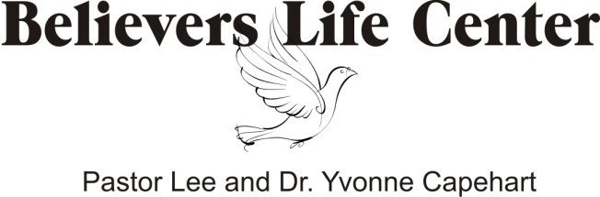

P.O. Box 15597
Pensacola, FL 32514
850-439-1410
believerslc@aol.com
www.believerslifecenter.org

